**ASTR 257 Project 2:**

**An HR Diagram of the Open Cluster M52**

**Overview**

The Hertzprung-Russell diagram is the bedrock of modern astrophysics. Photometry of coeval clusters of stars has enabled studies of stellar structure and evolution, populations, the distance ladder, and just about everything else. In this project, we will use the Nickel imager to collect multi-wavelength photometry of stars in the open cluster M52, which we will use to make an HR diagram and estimate the cluster’s age.

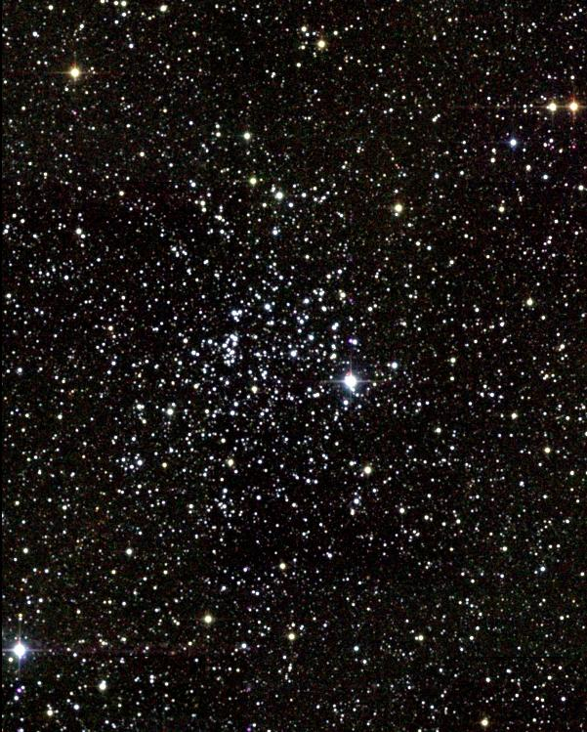

*Figure 1: Messier 52*

We’ve already used the Nickel telescope, so operations will be straight-forward. But instead of measuring the positions of stars—astrometry—we will measure the brightness of stars—photometry. We will use the pre-packaged code S-Extractor to measure the relative brightness of each star, including blended stars. We will then convert each star’s brightness into a magnitude using well-calibrated stars from the Landolt catalog. This is a new class, but my naïve guess is that this is our most challenging project. The S-Extractor code can be finicky and there are generally a lot of steps to the data reduction and analysis. Hang in there! Your reward will be an evening looking through the 36” Refractor.

**Learning Objectives:**

* Students will learn to plan and execute imaging observations with the Nickel telescope.
* Students will learn the basics of photometry.
* Students will learn to present their observations in a standard written format that is appropriate for publication.

**Planning Your Observations**

***Setup***

To first order, the observations you will obtain on M52 are similar to the ones you obtained on Pluto. So, to prepare for M52, repeat the same steps you used to plan the Pluto observation. Where is M52 and when is it observable? How will you know that the Nickel is looking at the M52 field? What filters should you use? How long should you integrate? What CCD calibrations will you need? Keep in mind that you are also repeating the Pluto observations tonight, so if you can share calibrations between the two programs, you will save time.

***Landolt Standards***

The usual way to calibrate ground-based optical photometry is to observe stars with known magnitudes, and compare their brightnesses to the star(s) you are studying. Astronomy hero Arlo Landolt has made a career of cataloging extremely precise photometry measurements on non-variable stars. Landolt’s catalog is available on various websites. As an example, try the WIYN consortium’s listing of recommended Landolt fields:

<http://www.wiyn.org/Observe/Landolt/recommendedfields.html>

Choose a field that is close in airmass to M52. Close in RA can be a decent proxy for close in airmass, but make sure to think this through. Landolt provides photometry in the UBVRI filters, so if you were planning to use different filters for M52, you might want to reconsider.

Note that extinction from the Earth’s atmosphere is a function of wavelength and airmass. Most photometrists observe multiple Landolt fields throughout the night to correct for airmass and stellar color, but this is beyond what I expect from you for this class. Just know that if you were publishing an HR diagram in a paper, you would need to correct for airmass and stellar color by observing multiple Landolt fields at different airmasses, and with different spectral type standards.

***Mosaics***

M52 is too big to fit on the Nickel CCD. If we wanted to map the entire cluster, we would have to do multiple pointings and then stitch (or mosaic) the different images into one much larger image. This is enough of a pain that we’re going to skip it for this class. Just find one reasonably dense region in the cluster and make an HR diagram from a single pointing.

***Approval of Observation Planning***

Before we start observing, present your plan of *exactly* what you’ll be doing. The more detail the better.

**To Be Completed During the Field Trip**

***Data Reduction***

The generic CCD imaging data reduction you did for Pluto applies to this project as well. However, note that CCD pixels can have a wavelength dependent response, so best practice is to take flats in each of the different filters that you use.

***S-Extractor***

Ordinarily, photometry of a single star involves adding up all of the counts in a region centered on the star, and then subtracting an estimated background contribution by looking at regions far away from the star of interest. Crowded-field photometry is more complicated because there isn’t always a clean region for estimating background, and because stars that are close to each other can be tricky to disentangle.

S-Extractor is an ancient computer program for performing crowded field photometry. While its guts are in Fortran, someone has kindly written a Python wrapper:

<https://docs.astropy.org/en/stable/api/astropy.io.ascii.SExtractor.html>

Install S-Extractor and run it on your M52 image. It will probably take you a few tries to determine a good set of input parameters. You will also need to run S-Extractor on your Landolt field. And of course, you will need to run it at multiple wavelengths.

***HR Diagram***

Convert your S-Extractor photometry into real astronomical magnitudes using the Landolt photometry. Plot your photometry as a color magnitude diagram. Is there a main sequence? Are there outliers? Why?

To estimate the age of M52, plot the Padova Stellar Evolution Isochrones (isochrones are lines of constant age):

<http://stev.oapd.inaf.it/cgi-bin/cmd>

Note that there are a lot of options here, and you should read through them, but the default is probably fine.

**Writeup (To Be Completed After the Field Trip)**

Please write descriptions of your Observations, Reductions and Results. Your Reductions section can be part of the Observations section, or it can be its own separate section. I expect your Observations section to be publication quality, your Reductions section to be clear, but not necessarily at the level of detail seen in publications, and your Results section to be extremely brief, just presenting your HR diagram and age estimate.